**XYZ Ads Airing Report Analysis**

**BY**

**Rahul Patil**

Contents

**Project Description:** 2

**Approach:** 2

**Tech-Stack Used:** 3

**Insights:** 4

**Brief about data:** 4

**1.Does the Pod position number affect the amount spent on Ads for a specific period of time by a company?** 5

**2.What is the share of various brands in TV airings and how has it changed from Q1 to Q4 in 2021?** 6

**3.Competitive analysis for the brands.** 7

**4.****Top 10 shows brands targeting for their different product.** 11

**5.** **Media plan to the CMO of Mahindra and Mahindra. Which audience should they target?** 15

**Summary:** 17

**Key project insight are:** 17

**Project Description:**

1. Advertising is a way of marketing your business in order to increase sales or make your audience aware of your products or services. Until a customer deals with you directly and actually buys your products or services, your advertising may help to form their first impressions of your business.
2. Target audience for businesses could be local, regional, national or international or a mixture. So they use different ways for advertisement.
3. Some of the types of advertisement are: Internet/online directories, Trade and technical press, Radio, Cinema, Outdoor advertising, National papers, magazines and TV.
4. Advertising business is very competitive as a lot of players bid a lot of money in a single segment of business to target the same audience. Here comes the analytical skills of the company to target those audiences from those types of media platforms where they convert them to their customers at a low cost.

# **Approach:**

* To successfully carry out this project we are going to use **SIX STEP** of Data Analysis Process i.e (Ask, Prepare, Process, Analyze, Share, Act)
* Ask step include asking right set of question which justify goal and give motivation to carry out analysis
* We have following Objective (reasons) to justify goal of this project.
  + Does the Pod position number affect the amount spent on Ads for a specific period of time by a company?
  + What is the share of various brands in TV airings and how has it changed from Q1 to Q4 in 2021?
  + Conduct a competitive analysis for the brands and define advertisement strategy of different brands and how it differs across the brands.
  + Mahindra and Mahindra wants to run a digital ad campaign to complement its existing TV ads in Q1 of 2022. Based on the data from 2021, suggest a media plan to the CMO of Mahindra and Mahindra. Which audience should they target? *Assume XYZ Ads has the ad viewership data and TV viewership for the people in India.
* Prepare: We have data in excel format which need to first clean, transform and load into correct format to make it suitable for analysis purpose.
* This step includes selecting right data, tools, data source to make project successful
* Process: Data we have in excel format we need to clean data such as removing null values, identifying data type, removing outliers which affect the analysis.
* Analyze: We are using excel itself which come with inbuilt statistical formulae and visualization tool to analyze data to draw insight.
* Share: we are showing data obtain from analysis in the form of row and column as well as chart wherever required for better and easy understanding.
* Act: Step include taking decision based on insight opt from this project.

# **Tech-Stack Used:**

* In this project we are going to perform medium level complex analysis using excel power query, pivot, formulae, chart are suitable tool to carry out analysis without investing in high technology and free open source tool Jupyter notebook.
* For using Jupyter notebook one must know the python programming language.
* Excel is not suitable for large dataset so it is advice to use good BI tool for large dataset for better analysis.

**Insights:**

## **Brief about data:**

Total number of columns=19

Total number of original record=731785

There are no missing values in dataset.

DAYPART columns has different category lets understand this

|  |  |  |  |  |  |  |  |  |
| --- | --- | --- | --- | --- | --- | --- | --- | --- |
| **DAYTIME** | **EARLY FRINGE** | **EARLY MORNING** | **EVENING NEWS** | **LATE FRINGE** | **OVERNIGHT** | **PRIME ACCESS** | **PRIME TIME** | **WEEKEND** |
| **9AM-4AM** | **3PM-7PM** | **4AM-10AM** | **5PM-7PM** | **10PM-1AM** | **12AM-5AM** | **6PM-8PM** | **6PM-11PM** | **SAT-SUN** |

1. Load dataset using power query and change data type of columns accordingly.
2. 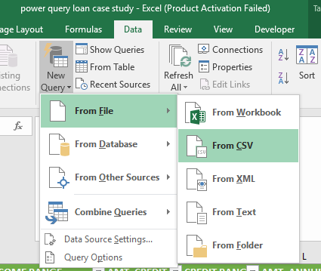Open blank excel workbook refer below Image to load data using power query.
3. Select file format accordingly from the folder where data is stored.
4. 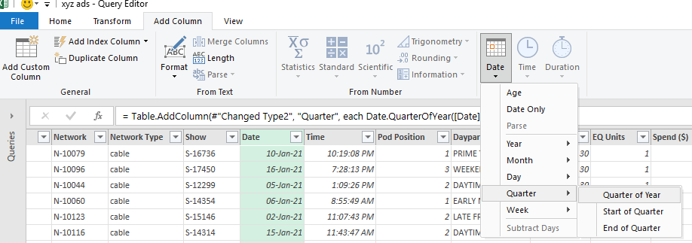Add new column called Quarter refer Image below.
5. 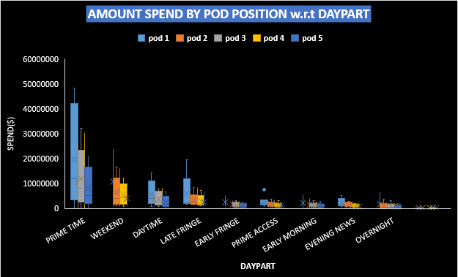**Does the Pod position number affect the amount spent on Ads for a specific period of time by a company?**

* Pod position refers to the placement of an advertisement within a podcast episode. Advertisers can choose to have their ads placed at the beginning, middle, or end of an episode, and the podcaster may offer different rates for each position.
* From above fig it is clearly visible that rate of pod position 1 is more than other pod position for all the different time of DAYPART.
* Prime time is most prefer time of people to watch podcast.
* Amount spend by company on pod position 1 in PRIME TIME is more as compare to other DAYPART

Pod position affect the effectiveness of the ad, as ads placed at the beginning of an episode may be more likely to be heard than ads placed at the end of an episode.

For example, if a company is looking to promote a new product and they want to maximize their ad's exposure, they might choose to place their ad in the first position of a popular podcast episode. This would increase the chances that people will hear/watch the ad and be more likely to remember the product when they make their purchase decisions.

On the other hand, if a company is looking to target a specific audience and they have a limited budget, they might choose to place their ad in the middle of a podcast episode that has a similar theme to their product. This would increase the chances that people who are interested in the topic will hear/watch the ad and be more likely to engage with it.

Overall, the pod position number can be an important consideration when it comes to ad placement. It is important for the company to consider their target audience and their budget when choosing the pod position.

1. **What is the share of various brands in TV airings and how has it changed from Q1 to Q4 in 2021?**
2. Maruti Suzuki has highest per share in each quarter as compare other brand.
3. Maruti Suzuki per share is avg 40 % in each quarter
4. Honda car in each quarter spent in between 3 to 4% except in Q2 share percentage decreased below 3% it might be due to tight budget in Q2
5. Mahindra & Mahindra per share increase in Quarter 2 as compare to Q1
6. In Q2 & Q3 Avg 30.50% contribution of Mahindra & Mahindra, then in last Quarter i.e. Q4 per share decline by 6%
7. Tata Motor Avg per share of 5% in first three Quarter
8. In last quarter Q4 amount spent of ad airing almost increased by 7%
9. Hyundai Motors India per share lies in between 12 to 13.70 % in each quarter.

## **3.Conduct a competitive analysis for the brands and define advertisement strategy of different brands and how it differs across the brands.**

* All the brands are heavily targeting people having cable type of network.
* Maruti Suzuki is a top competitor for all brand as it heavily investing in cable type of network for its Baleno car advertising
* Second competitor is Mahindra & Mahindra who’s mostly promoting their Mahindra New Thar.
* In Broadcast Type of network Number of times ads shown for Maruti Suzuki Baleno & Mahindra New Thar are almost equal, they are the major competitor in broadcast type of network
* Maruti Suzuki has highest contribution in TV airing Ads.
* Maruti Suzuki has ads running on all network, also as compare to other brands its contribution in all network is also high.
* Maruti Suzuki majorly focusing on **N-10040, N-10066, N-10014, N-10079, N-10041** this network
* Mahindra & Mahindra majorly focusing on **N-10116, N-10055** this network.
* Hyundai Motors India majorly focusing on **N-10014, N-10039** this network.
* Tata Motors majorly focusing on **N-10009, N-10051** this network.
* Honda Cars majorly focusing on **N-10117, N-10112** this network.
* Toyota majorly focusing on **N-10021, N-10005** this network.
* 30 second of Ads mostly use by all the brands.
* Honda Cars use the 10,15,30 second of ads.
* Hyundai Motors India use 15,30 and 75 sec of ads.
* Mahindra & Mahindra spend high amount on 15,20,30 and 60 second of ads.
* Maruti Suzuki spend high amount on 5,10,15 and 30 second of ads.
* Tata Motors spend high amount on 5,10,15 and 30 second of ads.
* Toyota spend high amount on 15,30 and 120 second of ads.
* Duration affect the price of ads arising if duration of ads greater than 30 its rate would be higher as multiple can be run in that duration.
* Short duration ads below 20 seconds can be good, its rate also low but it’s must convey all the important feature of product to convince the audience.

## **Top 10 shows brands targeting for their different product.**

* **Brand Name: Honda Cars**

|  |  |  |  |  |  |
| --- | --- | --- | --- | --- | --- |
| **Shows** | **Honda City** | **Shows** | **Honda Civiz** | **Shows** | **Honda Jazz** |
| S-14609 | 7 | S-15148 | 1028 | S-12680 | 483 |
| S-15551 | 6 | S-15146 | 815 | S-16010 | 424 |
| S-12279 | 5 | S-20311 | 761 | S-16697 | 360 |
| S-15892 | 4 | S-14098 | 634 | S-10037 | 299 |
| S-17321 | 4 | S-19337 | 624 | S-12900 | 280 |
| S-11786 | 3 | S-16483 | 586 | S-15079 | 273 |
| S-18782 | 3 | S-19877 | 577 | S-15148 | 266 |
| S-19883 | 3 | S-18294 | 560 | S-14666 | 265 |
| S-11816 | 2 | S-16747 | 556 | S-14098 | 253 |
| S-14082 | 2 | S-13776 | 495 | S-17278 | 233 |

* **Brand Name: Hyundai Motors India**

|  |  |
| --- | --- |
| **Shows** | **Hyundai I20** |
| S-19396 | 3444 |
| S-12551 | 2003 |
| S-15148 | 1401 |
| S-15146 | 1240 |
| S-12560 | 1227 |
| S-17278 | 1048 |
| S-19909 | 1025 |
| S-14098 | 1001 |
| S-17261 | 909 |
| S-18528 | 865 |

* **Brand Name: Mahindra and Mahindra**

|  |  |  |  |  |  |
| --- | --- | --- | --- | --- | --- |
| **Shows** | **Mahindra New Thar** | **Shows** | **Mahindra Scorpio** | **Shows** | **Mahindra XUV 700** |
| S-16994 | 2717 | S-21922 | 90 | S-21922 | 231 |
| S-12900 | 2439 | S-14098 | 66 | S-13307 | 100 |
| S-14098 | 2163 | S-17278 | 57 | S-17278 | 92 |
| S-15892 | 1893 | S-22486 | 54 | S-10725 | 69 |
| S-22486 | 1484 | S-13307 | 41 | S-22314 | 66 |
| S-19337 | 1447 | S-15779 | 37 | S-11608 | 41 |
| S-13726 | 1370 | S-15267 | 34 | S-12075 | 39 |
| S-21922 | 1335 | S-15146 | 33 | S-20290 | 37 |
| S-17910 | 1147 | S-10078 | 32 | S-19654 | 35 |
| S-11384 | 984 | S-20028 | 27 | S-18071 | 35 |

* **Brand Name: Maruti Suzuki**

|  |  |  |  |  |  |  |  |
| --- | --- | --- | --- | --- | --- | --- | --- |
| **Shows** | **Maruti Suzuki Baleno** | **Shows** | **Maruti Suzuki Celerio** | **Shows** | **Maruti Suzuki Ciaz** | **Shows** | **Maruti Suzuki Ertiga** |
| S-19407 | 3369 | S-16893 | 5 | S-19407 | 1295 | S-19407 | 228 |
| S-19396 | 2733 | S-10959 | 4 | S-19396 | 1289 | S-20470 | 82 |
| S-18528 | 1758 | S-11979 | 3 | S-18528 | 1037 | S-17878 | 58 |
| S-12551 | 1108 | S-11066 | 2 | S-12551 | 850 | S-20522 | 40 |
| S-14243 | 1094 | S-14000 | 2 | S-16747 | 811 | S-12722 | 38 |
| S-16747 | 1033 | S-20300 | 2 | S-14243 | 614 | S-14223 | 35 |
| S-12560 | 965 | S-10985 | 2 | S-20756 | 594 | S-19396 | 30 |
| S-13884 | 900 | S-20975 | 2 | S-13726 | 592 | S-11802 | 30 |
| S-20756 | 893 | S-21073 | 2 | S-15870 | 576 | S-10934 | 28 |
| S-15892 | 885 | S-17878 | 1 | S-12900 | 574 | S-10959 | 27 |

|  |  |  |  |  |  |
| --- | --- | --- | --- | --- | --- |
| **Shows** | **Maruti Suzuki Ignis** | **Shows** | **Maruti Suzuki Swift** | **Shows** | **Maruti Suzuki WagonR** |
| S-17208 | 5 | S-22451 | 13 | S-19407 | 409 |
| S-17881 | 4 | S-19790 | 6 | S-19396 | 197 |
| S-20412 | 4 | S-11417 | 5 | S-18528 | 159 |
| S-17466 | 4 | S-13465 | 5 | S-22451 | 124 |
| S-19363 | 3 | S-10321 | 4 | S-16886 | 124 |
| S-19198 | 2 | S-16729 | 4 | S-14243 | 107 |
| S-22528 | 2 | S-17337 | 4 | S-16729 | 99 |
| S-14026 | 2 | S-14276 | 3 | S-13726 | 98 |
| S-14961 | 2 | S-11267 | 3 | S-12900 | 97 |
| S-11419 | 1 | S-10322 | 3 | S-15870 | 84 |

* **Brand Name: Tata Motors**

|  |  |  |  |  |  |  |
| --- | --- | --- | --- | --- | --- | --- |
| **Shows** | **Tata Nexon** | **Shows** | **Tata Safari** | **Shows** | **Tata Tiago** | **Shows** |
| S-20470 | 605 | S-15892 | 441 | S-10725 | 39 | S-12560 |
| S-19396 | 532 | S-20470 | 219 | S-20522 | 34 | S-19396 |
| S-15892 | 516 | S-16747 | 216 | S-19523 | 33 | S-17401 |
| S-16747 | 454 | S-15870 | 216 | S-14708 | 25 | S-11824 |
| S-19055 | 454 | S-18528 | 211 | S-15892 | 21 | S-16386 |
| S-14243 | 280 | S-12279 | 196 | S-14252 | 21 | S-15870 |
| S-15870 | 274 | S-19396 | 193 | S-17878 | 20 | S-16388 |
| S-11229 | 264 | S-17319 | 169 | S-12722 | 18 | S-10130 |
| S-12551 | 259 | S-15148 | 156 | S-13323 | 18 | S-12279 |
| S-10725 | 258 | S-19055 | 155 | S-21127 | 18 | S-17347 |

* **Brand Name: Toyota**

|  |  |  |  |  |
| --- | --- | --- | --- | --- |
| **Toyota Etios** | **Shows** | **Toyota Fortuner** | **Shows** | **Toyota Innova** |
| 674 | S-17401 | 5 | S-12551 | 718 |
| 497 | S-12560 | 0 | S-16386 | 527 |
| 452 | S-19396 | 0 | S-19396 | 481 |
| 350 | S-11824 | 0 | S-11824 | 438 |
| 229 | S-16386 | 0 | S-15870 | 296 |
| 225 | S-15870 | 0 | S-21151 | 295 |
| 213 | S-16388 | 0 | S-19055 | 285 |
| 210 | S-10130 | 0 | S-15029 | 268 |
| 202 | S-12279 | 0 | S-12969 | 267 |
| 198 | S-17347 | 0 | S-14023 | 265 |

|  |  |  |  |  |  |  |
| --- | --- | --- | --- | --- | --- | --- |
| **Product** | **Broadcast Month** | **Date** | **Time** | **Pod Position** | **Dayparts** | **Duration** |
| Toyota Fortuner | NOV | 14-11-21 | 2:24:47 PM | 5 | WEEKEND | 30 |
| Toyota Fortuner | NOV | 14-11-21 | 5:40:22 PM | 6 | WEEKEND | 30 |
| Toyota Fortuner | NOV | 14-11-21 | 2:10:47 PM | 5 | WEEKEND | 30 |
| Toyota Fortuner | NOV | 14-11-21 | 2:09:40 PM | 5 | WEEKEND | 30 |
| Toyota Fortuner | NOV | 14-11-21 | 5:37:33 PM | 5 | WEEKEND | 30 |

1. Ads for Toyota Fortuner seem to be run on weekend in only Nov month.
2. Ads run in daytime between 2 to 5 pm
3. Targeting audience from **S-17401 show**

## **Mahindra and Mahindra wants to run a digital ad campaign to complement its existing TV ads in Q1 of 2022. Based on the data from 2021, suggest a media plan to the CMO of Mahindra and Mahindra. Which audience should they target?**

* Mahindra mostly focusing to promote their New Thar car in all daypart
* For XUV700 they are focusing audience from WEEKEND LATE FRINGE and EARLY MORNING
* For Scorpio they are focusing PRIME TIME and DAYTIME
* For Scorpio Mahindra spending more on 14th pod position it doesn’t seem to be worth it.
* People don’t watch too much ads after 2-3 ads they switch channel to watch other show.
* If Mahindra wants to increase the sales of Scorpio, they must focus on pod positon between 1 to 5 with duration of ads between 20 -30sec
* PRIME TIME and WEEKEND would be best time to run ads as most of audience watch their favourite shows on Weekend and between 7-11pm.

**Mahindra and Mahindra wants to run a digital ad campaign to complement its existing TV ads its must consider following point**

1. Try to make ads with duration less than 20 seconds which convey the message to audience if possible.
2. Short duration ads having lower rate which lower amount spent on ads campaign
3. PRIME TIME and WEEKEND will be preferring to target audience, most of viewer are watching shows on this time.
4. Consider to run ads between pod position 1 to 5 for the shows which have highest viewership.

# **Summary:**

* In this project we understand how to use SIX step process of Data analysis.
* In this project we learn to use excel pivot to perform ad-hoc analysis and different chart and graph to represent data.
* Learnt to use power query for data cleaning and feature engineering

## **Key project insight are:**

* + Maruti Suzuki and Mahindra & Mahindra are two major competitors in TV airing adds in automobile sector.
  + 50% of good time slot and pod positon are book by only this two Brands.
  + Shorter duration of ads would be good if it conveys the feature of product as its lower the expense on ads campaign.
  + Company can consider running multiple short duration ads.
  + PRIME TIME and WEEKEND are best time to target audience.
  + Running ads between pod position 1 to 5 are more likely to convert viewer into customer.
  + Consider TV showshaving higher viewership to run ads.